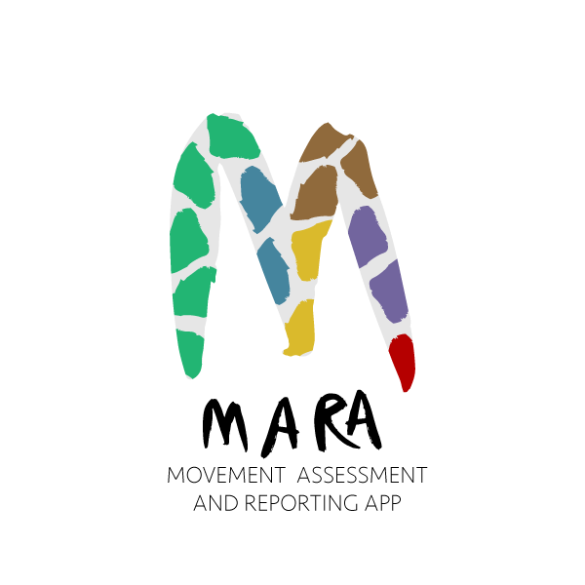

Scoring sheet for single participant using the Outcomes Framework

The following table provides an assessment option for a single participant using the Outcomes Framework for Dance Movement Therapy (Dunphy, Lebre & Mullane, 2020, www.makingdancematter.com.au). Therapists and participants may choose to assess all outcomes in order to identify areas that could be supported in a DMT process or select a smaller number of outcomes based on pre-identified program goals, or ideas for focus that arose in interview.
This process could be completed here on this form, on app MARA www.makingdancematter.com.au/help/ or on Excel documents available here www.makingdancematter.com.au/about/outcomes-framework/.
Use in conjunction with Outcomes Framework available on www.makingdancematter.com.au/about/outcomes-framework/ that provides a full explanation and definitions for each item. Space is provided for up to four scores and a mean, which allows therapists to record the potential range of scores for each item that might be evident in a session/s.
The mean for each domain and sub-domain can be calculated from the items within that sub-domain, allowing the therapist to identify areas of strength and potential development at the sub-domain level.

OUTCOME DOMAIN 1 PHYSICAL: Towards a stable, mobile, functional & expressive body
 | SUB-DOMAIN & OBJECTIVES Scoring: 1 (minimal) to 10 (maximum conceivable)
 | 1.1 | Body parts: awareness, activation, connection | Score 1 | Score 2 | Score 3 | Score 4 | Mean
 | 1.1.1 | Use of breath to support movement
 | 1.1.2 | Activation of body parts: upper, lower body
 | 1.1.3 | Activation of body hemispheres left, right
 | 1.1.4 | Body parts connection: centre to extremities, head to tail connections
 | 1.1.5 | Body parts connection: upper and lower body
 | 1.1.6 | Body halves connection: right and left sides
 | 1.1.7 | Body parts connection: diagonal movement
 | 1.1.8 | Sequencing of body parts in movement
 | 1.1.9 | Self-synchrony: body parts moving in rhythm with oneself
 | 1.1.10 | Control of movement succession
Sub-domain Mean

 | 1.2 | Space: Body in space | Score 1 | Score 2 | Score 3 | Score 4 | Mean
 | 1.2.1 | Kinaesphere: access to near-, mid- and far- reach space
 | 1.2.2 | Movement planes: access to vertical, horizontal, sagittal planes
 | 1.2.3 | Spatial intention: mover identifies and uses directions or points in space
 | 1.2.4 | Levels in space: access to low, medium, high levels
 | 1.2.5 | Managing body boundaries in space
Sub-domain Mean

 |  | Shape: Body shaping | Score 1 | Score 2 | Score 3 | Score 4 | Mean
 | 1.3.1 | Shape Flow: access to Shape Flow, representing a relationship of the body to itself
 | 1.3.2 | Directional: access to Directional Shaping of the body
 | 1.3.3 | Carving: access to Space Carving, the body’s active and three-dimensional interaction with the volume of the environment
 | 1.3.4 | Shape qualities: access to Shape qualities, opening and closing
Sub-domain Mean

 | 1.4 | Effort: Movement qualities | Score 1 | Score 2 | Score 3 | Score 4 | Mean
 | 1.4.1 | Weight: access to Active (light - strong) and Passive (limp - heavy) Weight Efforts
 | 1.4.2 | Space: access to Direct – Indirect Space Efforts
 | 1.4.3 | Time: access to Sudden –Sustained Time Efforts
 | 1.4.4 | Flow: Access to Bound - Free Flow Efforts
 | 1.4.5 | Effort combinations: access to combinations of Effort elements
 | 1.4.6 | Effort phrasing: access to Effort phrasing
Sub-domain Mean

 | 1.5 | Fitness and release | Score 1 | Score 2 | Score 3 | Score 4 | Mean
 | 1.5.1 | Stamina
 | 1.5.2 | Strength
 | 1.5.3 | Flexibility
 | 1.5.4 | Balance
 | 1.5.5 | Release of physical tension
Sub-domain Mean

OUTCOME DOMAIN 2 CULTURAL: Towards a creative, aesthetic, expressive self
 | SUB-DOMAIN & OBJECTIVES Scoring: 1 (minimal) to 10 (maximum conceivable)
 | 2.1 | Creativity and aesthetic sense | Score 1 | Score 2 | Score 3 | Score 4 | Mean
 | 2.1.1 | Creativity expressed
 | 2.1.2 | Experience of aesthetic enrichment
 | 2.1.3 | Aesthetic decision-making
Sub-domain Mean

 | 2.2 | Cultural appreciation and belonging | Score 1 | Score 2 | Score 3 | Score 4 | Mean
 | 2.2.1 | Appreciation of diversity and difference of cultural expression
 | 2.2.2 | Sense of belonging to a shared cultural heritage experienced
Sub-domain Mean

OUTCOME DOMAIN 3 EMOTIONAL: Towards healthy, regulated emotions
 | SUB-DOMAIN & OBJECTIVES Scoring: 1 (minimal) to 10 (maximum conceivable)
 | 3.1 | Emotional expression | Score 1 | Score 2 | Score 3 | Score 4 | Mean
 | 3.1.1 | Identification of own feeling or emotional states
 | 3.1.2 | Expression of own feeling or emotional states
 | 3.1.3 | Experience of fun, pleasure, enjoyment
 | 3.1.4 | Access to playfulness
 | 3.1.5 | Access to full range and intensity of affects
 | 3.1.6 | Sense of positive body image
 | 3.1.7 | Sense of confidence in self
Sub-domain Mean

 | 3.2 | Emotional regulation | Score 1 | Score 2 | Score 3 | Score 4 | Mean
 | 3.2.1 | Expression of feelings and emotions appropriate to current situation
 | 3.2.2 | Capacity to cope with challenges and difficulties
 | 3.2.3 | Release of psychological tension
Sub-domain Mean

OUTCOME DOMAIN 4 COGNITIVE: Towards an Active, enquiring mind
SUB-DOMAIN & OBJECTIVES Scoring: 1 (minimal) to 10 (maximum conceivable)
 | 4.1 | Attention and initiative | Score 1 | Score 2 | Score 3 | Score 4 | Mean
 | 4.1.1 | Attention to activity
 | 4.1.2 | Energy attuned appropriately to activity
 | 4.1.3 | Indication of preferences and choice-making
 | 4.1.4 | Independent initiation of an action or activity
 | 4.1.5 | Leading, taking ownership of an activity
Sub-domain Mean

 | 4.2 | Memory | Score 1 | Score 2 | Score 3 | Score 4 | Mean
 | 4.2.1 | Sense of enthusiastic anticipation evident
 | 4.2.2 | Recall of movement sequences
 | 4.2.3 | Recall of themes or ideas from previous activities
 | 4.2.4 | Meaningful evocation and exploration of life memories
Sub-domain Mean

 | 4.3 | Executive function | Score 1 | Score 2 | Score 3 | Score 4 | Mean
 | 4.3.1 | Following directions
 | 4.3.2 | Processing speed
 | 4.3.3 | Reflective capacity
 | 4.3.4 | Organisation of thinking, making connections, identifying patterns
 | 4.3.5 | Attribution of mental states to oneself and other (Theory of mind)
Sub-domain Mean

OUTCOME DOMAIN 5 SOCIAL: Towards satisfying, reciprocal relationships
 | SUB-DOMAIN & OBJECTIVES Scoring: 1 (minimal) to 10 (maximum conceivable)
 | 5.1 | Embodied (non-verbal) communication | Score 1 | Score 2 | Score 3 | Score 4 | Mean
 | 5.1.1 | Comfort in proximity to others
 | 5.1.2 | Appropriate eye gaze or contact
 | 5.1.3 | Appropriate facial expression
 | 5.1.4 | Appropriate use and reception of touch
 | 5.1.5 | Appropriate physical contact or connection with others
 | 5.1.6 | Appropriate use of personal space in relation to others, including body boundaries
Sub-domain Mean

 | 5.2 | Social reciprocity | Score 1 | Score 2 | Score 3 | Score 4 | Mean
 | 5.2.1. | Appropriate response to offer of social connection
 | 5.2.2. | Appropriate initiation, sustainment, release of social connection
 | 5.2.3 | Appropriate give and take in relationship, turn-taking
 | 5.2.4 | Synchrony of movement with others
Sub-domain Mean

 | 5.3 | Expressive (including verbal and vocal) communication | Score 1 | Score 2 | Score 3 | Score 4 | Mean
 | 5.3.1 | Identification of feelings or emotional states of others
 | 5.3.2 | Socially acceptable or appropriate response to emotions of others
 | 5.3.3 | Emotional connection with others
 | 5.3.4 | Receptive communication
 | 5.3.5 | Expressive vocal or verbal communication
 | 5.3.6 | Appropriate vocal or verbal communication
 | 5.3.7 | Capacity to reflect on experiences and to communicate them
Sub-domain Mean

OUTCOME DOMAIN 6 INTEGRATION: WHOLENESS, VITALITY, ALIVENESS
 | SUB-DOMAIN & OBJECTIVES Scoring: 1 (minimal) to 10 (maximum conceivable)
 | 6.1 | Sense of integration within self | Score 1 | Score 2 | Score 3 | Score 4 | Mean
 | 6.1.1 | Integration of past, present and future dynamic (embodied) self
 | 6.1.2 | Adaptation to adversity, coping, resilience
 | 6.1.3 | Integration of whole self: sensations, feelings, thoughts, imagination
 | 6.1.4 | Embodied sense of a positive future
 | 6.1.5 | Experience of flow state
Sub-domain Mean

 | 6.2 | Sense of integration between self and outside world. | Score 1 | Score 2 | Score 3 | Score 4 | Mean
 | 6.2.1 | Resonance: sense of felt unity with music, partner or other stimulus
 | 6.2.2 | Embodied pleasure and sensuality
 | 6.2.3 | Experience of sense of meaning, spiritual or numinous connection or transcendence
 | 6.2.4 | Sense of belonging and becoming, connection and contribution
Sub-domain Mean

Therapist undertaking assessment
Name of therapist
Signature
Date of report
Therapists’ comments

